**Checkie by AngPhie**

**A Simple To-Do App with Sticky Notes**

Anggela F Syaloomitha Taek (001202300153) & Shofiyyah Abidah Marpaung (001202300174)

**Overview**

Checkie by AngPhie is a simple and playful web-based to-do list application featuring a sticky notes wall. Designed for individuals seeking a fun, visual, and minimalistic task management tool, this application enables the creation, editing, archiving, and deletion of tasks, as well as the addition of colorful sticky notes to capture quick thoughts or reminders in an engaging way.

The development of this application was divided into two main responsibilities: frontend and backend. The frontend was developed by Shofiyyah using HTML, CSS perfect for lightweight applications. The backend was handled by Anggela, using Express and Node.js to efficiently manage API endpoints and handle CRUD operations. JSON was chosen as the data storage format because the format is simple, easy to read, and suitable for small-scale development applications such as Checkie by Angphie. Docker was implemented to simplify deployment, ensuring consistent environments across development and production by containerizing both the frontend and backend services.

**Tech Stack**

* Frontend: HTML and CSS (by Shofiyyah )
* Backend: Node.js with Express.js (by Anggela)
* Data Storage: JSON
* Deployment: Docker (both)

**Features**

* Add, edit, and delete tasks with due date, priority, and tags.
* Archive completed tasks.
* Add, edit, and delete sticky notes with random pastel colors.
* Clean and responsive UI design.

**Documentation**

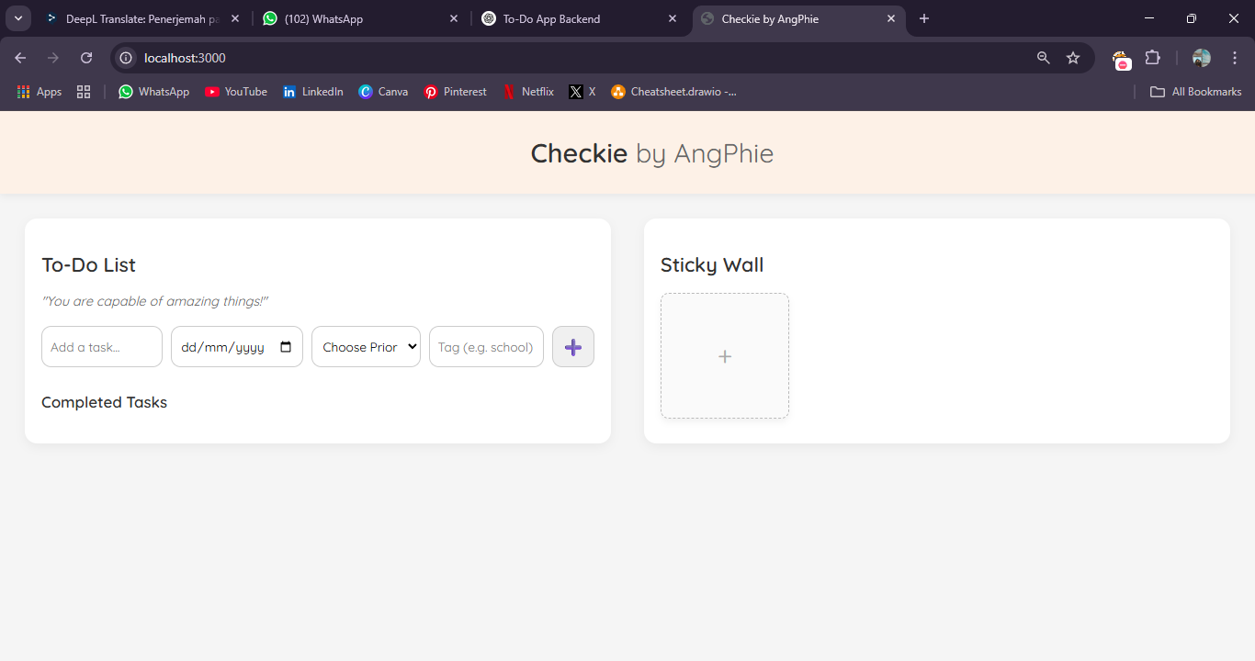

page overview

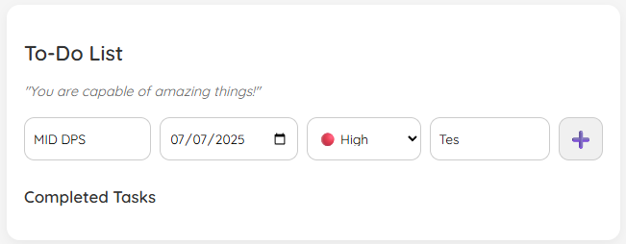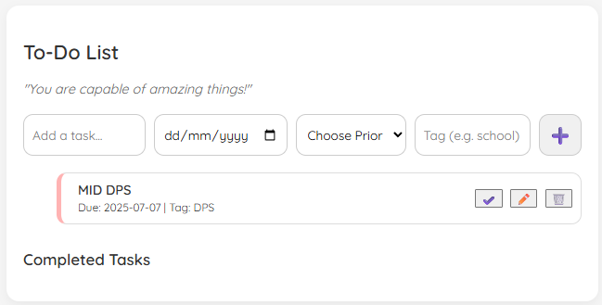

add a task

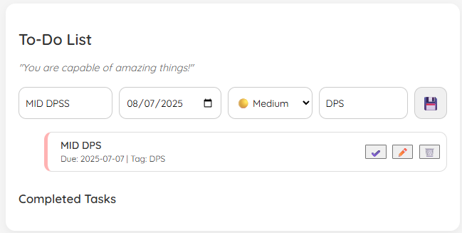

edit a task

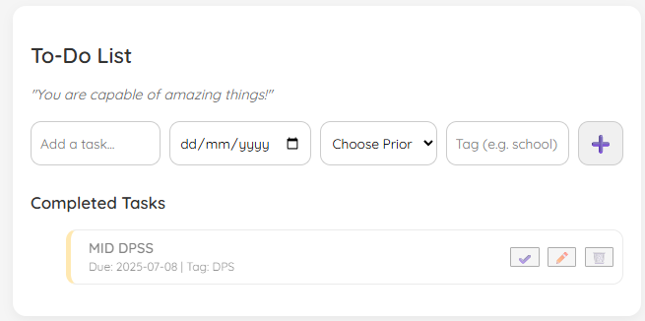

complete a task

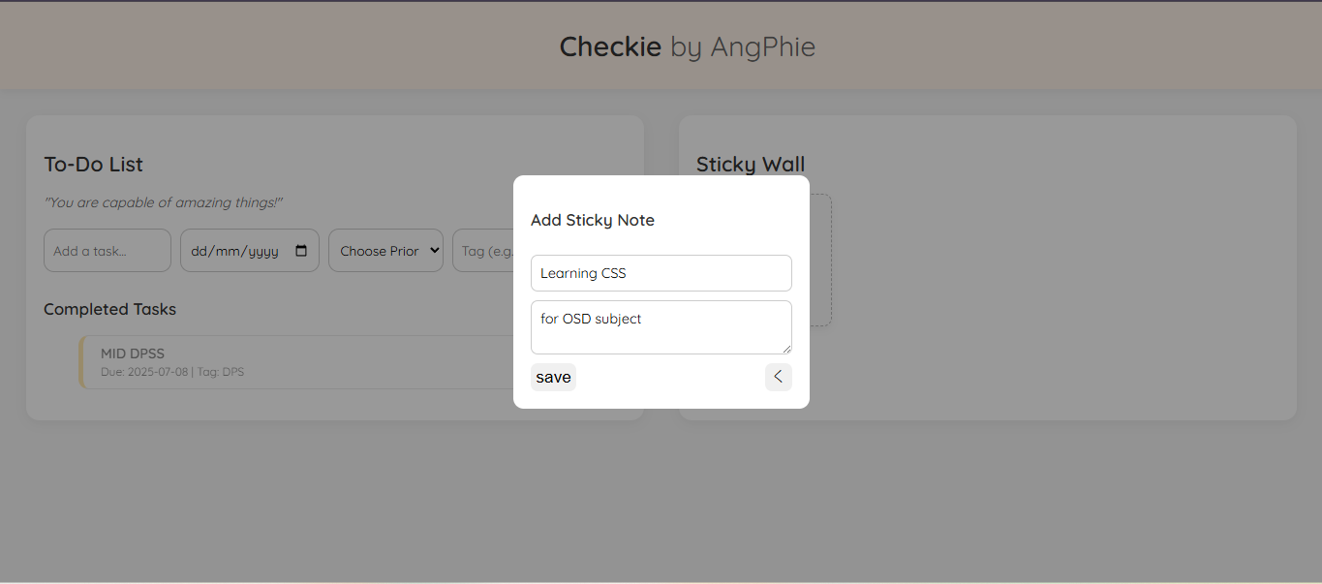

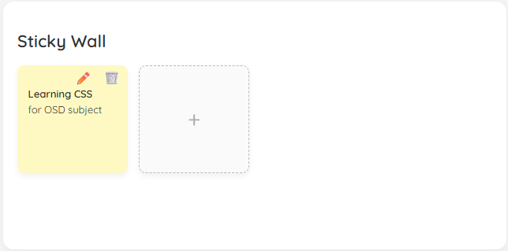

add a sticky note

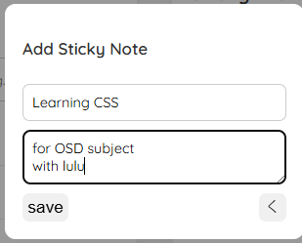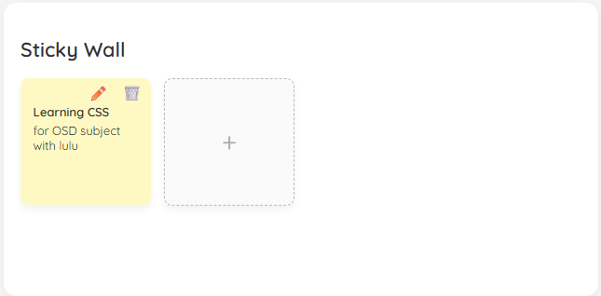

edit a sticky note

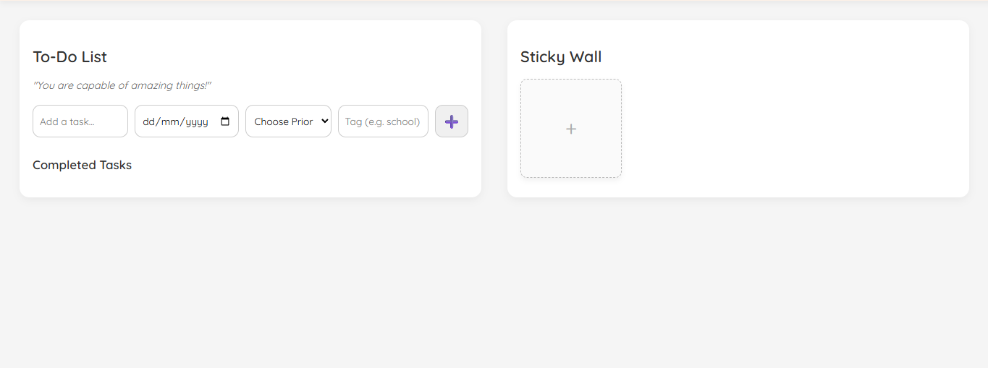

delete a task and a sticky note

**Deployment with Docker**

Step 1: Design the project structure for frontend and backend

Step 2: Create Dockerfile for frontend

Step 3: Create docker-compose.yml align with /frontend

Step 4: Define frontend service in docker-compose.yml

Step 5: Create Dockerfile for backend

Step 5: Define backend service in docker-compose.yml

Step 6: Build & run with docker-compose